THE WOMAN’S BAPTIST E AND M CONVENTION OF SOUTH CAROLINA
Mrs. Hilda D. Gadsden, President
1434 Amber Lane, Charleston, SC 29407
(843) 763-1385 Home | (843) 442-5110 Mobile
macksr@bellsouth.net

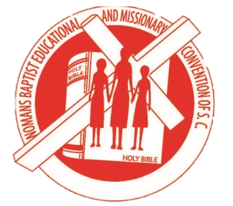

BANQUET TICKET ORDER FORM

Name Person requesting ticket: _______________________________________________________
Address: __________________________________________________________________________
City: ___________________________________ State _____________ Zip Code _______________
Home Telephone: ___________________________ Cell Telephone: _________________________
Name of Association (if applicable): _______________________________________________________
Name of Union (if apply): ____________________________________________________________
Name of Church (if apply): __________________________________________________________

Banquet ($50.00 per ticket) | Number of Ticket/s | Total Amount Paid

Mail your request form and money to the Treasurer by June 1, 2023
Payment type: (1) Church of Organizational Checks (2) Money Order or Cashier Check

NO PERSONAL CHECKS!
Mail to: Ms. Sandra Short, Treasurer
404 Pine Hill Lane
Goose Creek, SC 29445
(843) 478-2216

ALL TICKETS REQUESTED MUST BE PAID FOR IN ADVANCE!
Banquet Colors: Black & Gold

